This is the Title of Your Manuscript: An Optional Subtitle

February 19, 2026

Abstract This is the abstract. Your abstract should be written in the original language of your manuscript. The total word count of the abstract should be between 150 and 250 words. The abstract should not include an abbreviation or a citation.

JEL Codes A00, B1.

Keywords economics, manuscript template, typesetting.

1. Introduction
The first section of your manuscript is the introduction. Sections (Heading 1 style in this template) and subsections (Heading 2 style in this template) should be numbered consecutively (see below).
The main text (Normal style in this template) is left aligned without indentation. The font type is Times New Roman, and the font size is 12pt. Please do not use boldface or underlined text. The italic shape should be used for emphasis.

2. Another Section
This is another section. Please be reminded that authors are responsible for ensuring that the manuscript is properly prepared for double-blind peer review. The manuscript must not include (i) author information or (ii) any other information that reveals the identity of the author(s). References to the authors’ own work should be written in the third person.

2.1. Here is a Subsection
A subsection is a second-level section, and they should be numbered consecutively. The third- and higher-level sections should not be numbered.

A Third Level Section Now
The third-level sections correspond to Heading 3 in this template. To ensure readability, we encourage authors to not use fourth- or higher-level sections. However, paragraph headings could be useful.
A Paragraph Heading. There should not be a line break following a paragraph heading; the text should follow directly. It is essential to enter a “dot” after the paragraph heading.

3. Display Items
The typical display items are (i) equations, (ii) figures, and (iii) tables. All of these items should be centered and numbered consecutively using Arabic numerals. This section of the template provides some examples.

3.1. Equations
An equation should be entered using the equation editor. Use the “Insert functionality” in Microsoft Word to find the “Equation” button, and enter your equation.
$E=mc^{2}$ (1)
Equation numbers should appear on the right-hand side of the page. Use “Tabs” to enter and justify the equation number.
If you need to insert an inline equation such as this one, $F=ma$, or any mathematical object such as $x∈R$, you should still use the Insert equation functionality.
In manuscripts with linear algebra content, boldface mathematical objects can be used for vectors and matrices:
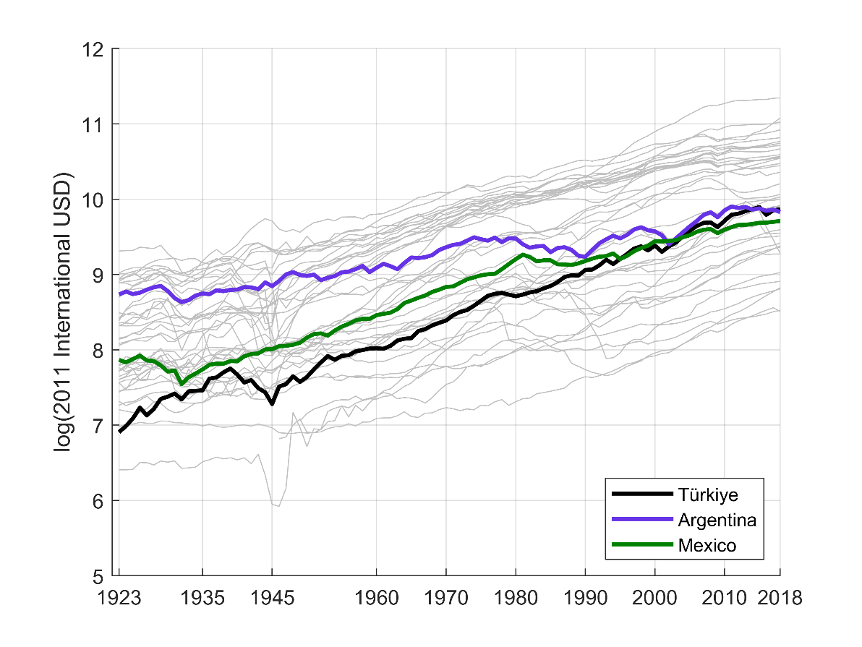
Figure 1. GDP per capita in selected countries (natural log)
Notes: This figure shows GDP per capita in natural logarithmic units of 2011 international USD. The original data source is Maddison Historical Statistics (Bolt & van Zanden, 2024).

$y=Xβ+u$ (2)
3.2. Figures
The figures should appear on the top of the page within the main text, and they should be numbered consecutively using Arabic numerals (1, 2, …).
Each figure should have a caption just below the figure itself.
Ideally, each figure should have a Notes section inserted just below the figure caption. The Notes section can be used to give some explanatory information about the figure, cite original data sources, or indicate whether the figure shows authors’ own computations.
You can insert figures in any format (pdf, png, jpg, etc.), but make sure that each figure has a sufficiently high resolution (dpi value) so that they would not pixelate when zoomed in or published.
Figures should have a solid white background for better visibility. Also, the text within figures should use a single font type, and the font size should be large enough but not too large.
Table 1. Calibrated parameters
 | Support | Value | Source or target
Subjective discount rate | $$ρ∈\left(0,+∞\right)$$ | 0.032 | $r = 0.058$ in 2017
Depreciation rate | $$δ∈\left(0,1\right)$$ | 0.048 | Penn World Table, 2018
Notes: This table summarizes our benchmark calibration. Please see the text for details.
3.3. Tables
The tables should appear on the top of the page within the main text, and they should be numbered consecutively using Arabic numerals (1, 2, …).
Each table should have a caption just above the table itself.
Ideally, each table should have a Notes section inserted just below. The Notes section can be used to give some explanatory information about the table, cite original data sources, or indicate whether the table shows authors’ own computations.
Tables should not normally use vertical borders. The font size should not be lower than 10pt. If your table is sufficiently large (many columns), you can use a landscape page layout. A sufficiently long table (many rows) can be divided to appear on two or more pages.

4. Theorem environments
If you need to insert a definition, lemma, proposition, theorem, etc., use a paragraph heading with a boldface caption and italic text. Lemmas, propositions, and theorems should always be followed by a proof environment, but the proofs can be shared in appendices.
Proposition 1. There exists a unique solution to the consumer’s problem.
⸻Proof of Proposition 1: Please see Appendix A. □
Theorem environments should be consecutively numbered within each type. Please see the examples below.
Definition 1. A general equilibrium of the model economy is a price vector $p^{*}∈R_{++}^{n}$ that clears all markets simultaneously. □
Proposition 2. There exists a unique and locally stable general equilibrium.
⸻Proof of Proposition 2: Please see Appendix A. □

5. Citations and quotations
The Efil Journal of Economic Research follows the most recent style guidelines of the American Psychological Association (APA) for references and citation.
The citations within the text must be in the author-year format.
- Parenthetical examples:
(Akyüz & Boratav, 2003, p. 1459), (Acemoglu et al., 2006), (Yeldan, 2009)
- Narrative examples:
Akyüz & Boratav (2003, p. 1459), Acemoglu et al. (2006), Yeldan (2009)
For quotations less than 40 words, integrate the quotation into your own text with a proper citation. See the example below:
The December 1999 IMF stabilization program in Turkey faced certain difficulties “because the program was launched in the face of structural problems and fragilities on many fronts, notably in public finances and the banking sector.” (Akyüz & Boratav, 2003, p. 1550).
For quotations longer than 40 words, use an indented block without a quotation mark. See the example below:
Akyüz & Boratav (2003, p. 1560) describe the structure of Turkey’s debt problem as follows:
The Turkish debt problem is predominantly an internal one. With high and volatile inflation, real interest rates tend to hover at double digit rates, necessitating large primary fiscal surpluses in order to check a rapid build up of domestic debt, but this in turn depresses growth, thereby making it more difficult to sustain government debt without recourse to Ponzi financing.

6. Footnotes
Footnotes can be used to give additional information and comments, including an in-text citation in the author-year format. However, footnotes should not give the full bibliographic details of a cited material. Footnotes should not contain figures or tables, but in-line equations are allowed. Footnotes should be numbered consecutively using Arabic numerals.

References
The references list should be prepared in accordance with the APA style guidelines for each type of cited materials.
- Books:
- Svendsen, S., & Løber, L. (2020). The big picture/Academic writing: The one-hour guide (3rd digital ed.). Hans Reitzel Forlag.
- Hygum, E., & Pedersen, P. M. (Eds.). (2010). Early childhood education: Values and practices in Denmark. Hans Reitzels Forlag.
- Chapter in an edited book:
- Dillard, J. P. (2020). Currents in the study of persuasion. In M. B. Oliver, A. A. Raney, & J. Bryant (Eds.), Media effects: Advances in theory and research (4th ed., pp. 115–129). Routledge.
- Journal article:
- Rybaczewska, M., & Sparks, L. (2022). Ageing consumers and e-commerce activities. Ageing and Society, 42(8), 1879–1898.
See the APA Style for other types of materials such as unpublished working papers, newspaper articles, data repositories, online resources, and dissertations/theses.
The list of references should be alphabetic (please see the details given in the APA style) and should have a hanging paragraph style:
Dillard, J. P. (2020). Currents in the study of persuasion. In M. B. Oliver, A. A. Raney, & J. Bryant (Eds.), Media effects: Advances in theory and research (4th ed., pp. 115–129). Routledge.
Hygum, E., & Pedersen, P. M. (Eds.). (2010). Early childhood education: Values and practices in Denmark. Hans Reitzels Forlag.
Rybaczewska, M., & Sparks, L. (2022). Ageing consumers and e-commerce activities. Ageing and Society, 42(8), 1879–1898.
Svendsen, S., & Løber, L. (2020). The big picture/Academic writing: The one-hour guide (3rd digital ed.). Hans Reitzel Forlag.

Appendix A. How to structure the appendices?
If your manuscript has appendices, uppercase Latin letters should be used in structuring them.
An appendix is a first-level section, and the heading style should be consistent with section headings in the main text.
Each new appendix should start on a new page.
The captions, labels, and numbers of equations, figures, and tables in an appendix have their own style. For instance, the third equation in your Appendix B is equation (B.3). Similarly, the first table in your Appendix A is Table A.1, and the fourth figure in your Appendix B is Figure B.4. As in the main text, these display items should be put at the center of the column.

Here is an additional information: The Efil Journal of Economic Research do not use endnotes.

